# Lab 1 - Connecting Your On-Premise Network and Directory Services to AWS

1. Connect to your on-premise network with AWS Transit Gateway and VPN
2. Connect your on-premise Active Directory domain to your AWS environment.

The goal is to connect their on-premise network (physical servers and systems) to the AWS cloud.

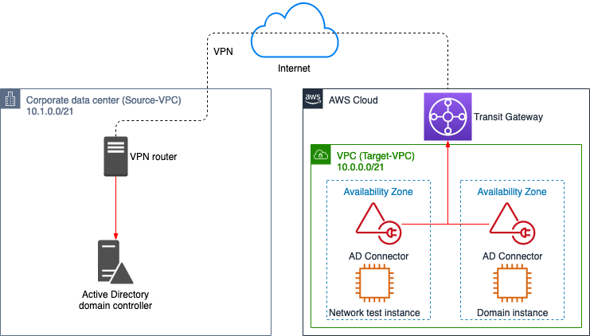

Transit Gateway: A service that connects your VPCs and on-premise networks.

Use AWS Transit Gateway and VPN to connect your on-premise network to AWS.

**Task 1: Transit gateway**

1.1 Open vpc, select this TG

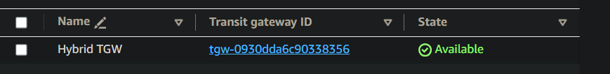

1.2 attachments

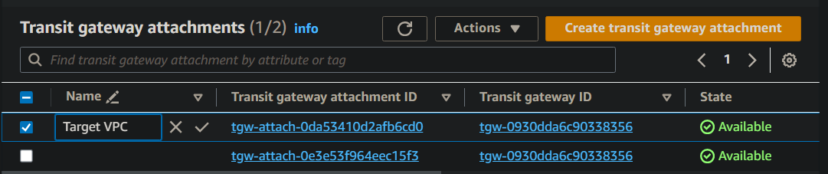

1.3 enable access to your remote network from your VPC by creating an AWS Site-to-Site VPN connection

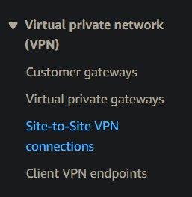

1.4 download the config (VPN config file)

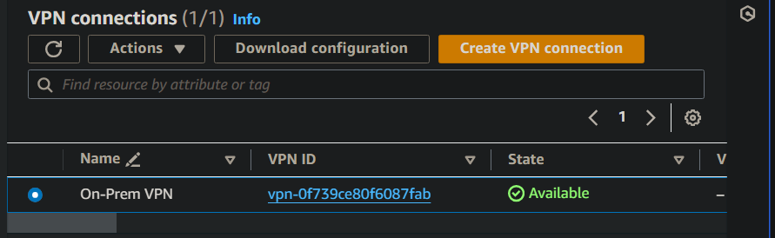

1.5 from the file, note these values

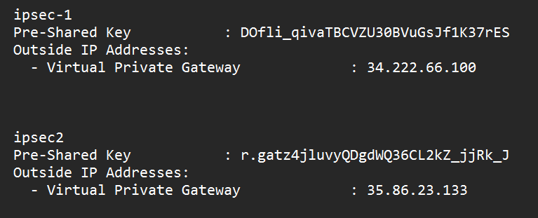

1.6

**Task 2: Establish the VPN tunnel and route traffic**

2.1 to connect, use this EC2 instance

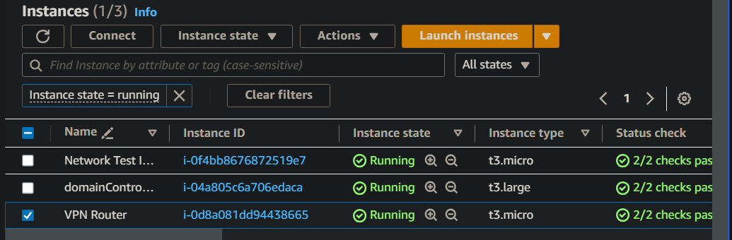

2.2 run this code - store in variables

*TUNNEL_1_PRESHARED_KEY=Tunnel1 - Pre-Shared Key*

*TUNNEL_1_IP_ADDRESS=Tunnel1 - Outside IP Addresses - VGW*

*TUNNEL_2_PRESHARED_KEY=Tunnel2 - Pre-Shared Key*

*TUNNEL_2_IP_ADDRESS=Tunnel2 - Outside IP Addresses - VGW*

2.3 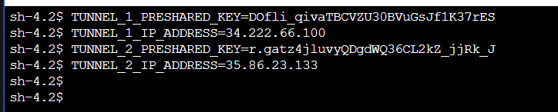

2.4 router s/w = strongSwan Here, we have to put the above values in the software’s files to make the connection

sudo sed -i "s/TUNNEL_1_IP_ADDRESS/$TUNNEL_1_IP_ADDRESS/g" /etc/strongswan/ipsec.conf

sudo sed -i "s/TUNNEL_2_IP_ADDRESS/$TUNNEL_2_IP_ADDRESS/g" /etc/strongswan/ipsec.conf

2.5

sudo sed -i "s/TUNNEL_1_IP_ADDRESS/$TUNNEL_1_IP_ADDRESS/g" /etc/strongswan/ipsec.secrets

sudo sed -i "s/TUNNEL_2_IP_ADDRESS/$TUNNEL_2_IP_ADDRESS/g" /etc/strongswan/ipsec.secrets

sudo sed -i "s/TUNNEL_1_PRESHARED_KEY/$TUNNEL_1_PRESHARED_KEY/g" /etc/strongswan/ipsec.secrets

sudo sed -i "s/TUNNEL_2_PRESHARED_KEY/$TUNNEL_2_PRESHARED_KEY/g" /etc/strongswan/ipsec.secrets

2.6 the files now show the information

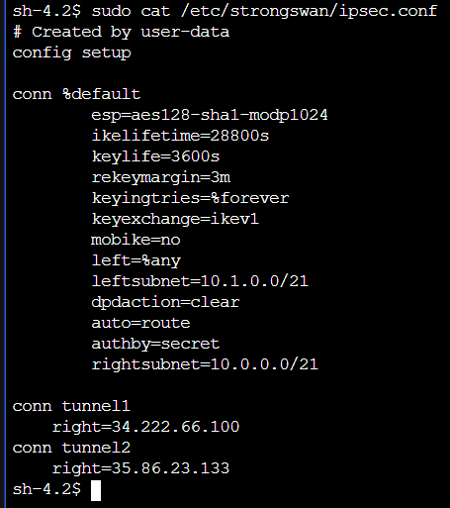

2.7 to establish the VPN connection, run these

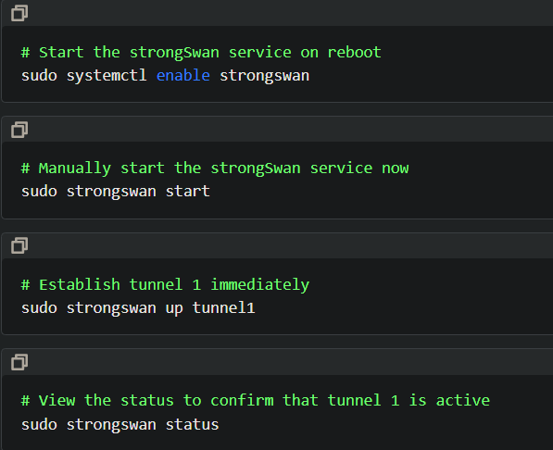

2.8 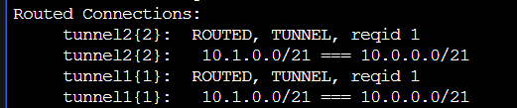

2.9 Both the VPC and the transit gateway need to know where to send traffic to the destination network. You must enter a route into a VPC route table and the transit gateway route table.

2.10 select this route table

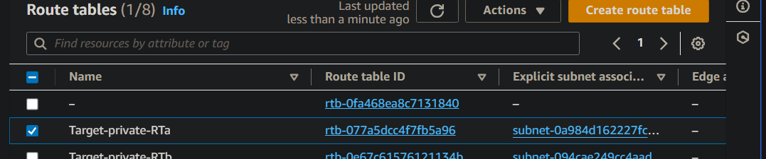

2.11 

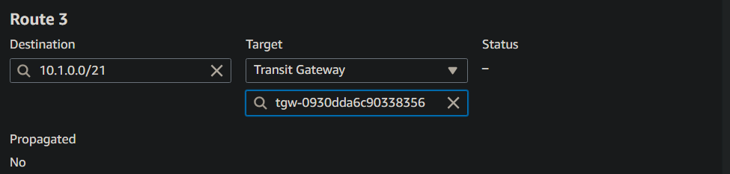

**Task 3 -traffic**

3.1 create a route in transit gateway route table - for traffic

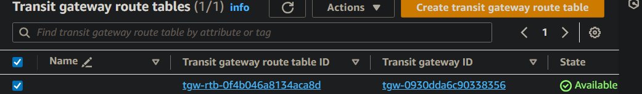

3.2 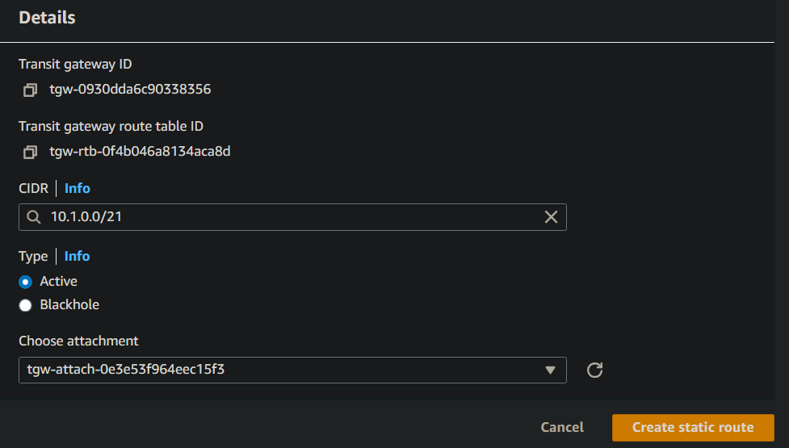

3.3

**Task 4 - test the VPN**

4.1 open this instance

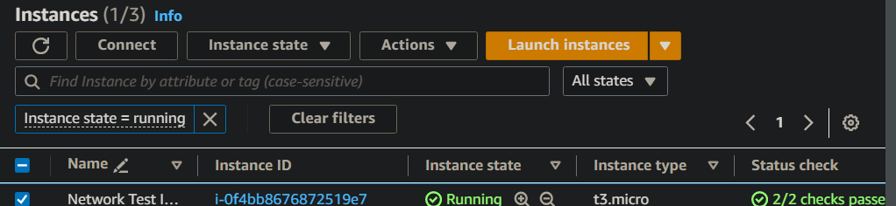

4.2 run this to get traffic from domain controller (on-premises)

ping DOMAIN_CONTROLLER_IP

4.3 